Quiet Waters Park - Retreat Park

Report of Survey of

Citizens’ Preferences for Future Development

Quiet Waters Park’s newest addition, the Retreat Park, encompasses 19 acres of undeveloped land adjacent to the main park, with expansive views of the South River and Loden Pond. To guide its future use and development, Anne Arundel County’s Department of Recreation and Parks, in collaboration with the Department of Public Works (DPW), convened a Stakeholders group of eleven local citizens.

On October 22, 2024, DPW proposed three designs for the Retreat Park and invited Stakeholders to provide public feedback by December 7. Each design included a main path, trails, viewing areas by the river and pond, and thematic amenities:

**A. Wellness and Mindfulness** – Promoting relaxation and reflection.

**B. Art and Culture** – Highlighting creativity and educational spaces.

**C. Wildlife Sanctuary and Habitat Restoration** – Emphasizing conservation and habitats.

Two members of the Stakeholders group, the Annapolis Neck Peninsula Federation (ANPF) and Friends of Quiet Waters Park, gathered community input through an online survey. In response to public interest, they also introduced a fourth option: **C - Modified**, featuring basic paths and trails with the most minimal amenities, namely grassy viewing areas, benches and picnic tables.

The survey drew significant engagement, **952 respondents of whom** **80% favored the more natural and simple park designs, C and C - Modified**. This large response clearly indicates the public’s preference for minimal to no development while fostering environmental education and sustainability. Individual comments also reflected a strong desire for direct experience of the beauty and tranquility of the natural world.

Access to the entrance of the Retreat Park by a vehicular road and parking lot was soundly rejected with 88% of respondents preferring a pedestrian path.

This feedback mirrors earlier community discussions at an ANPF visioning session on April 3, 2022 where participants expressed a fervent desire to *“Keep It Natural. Make It Native.”* The public values the Retreat Park as an experience of Nature, a magnificent and attractive haven for people and animals, offering peace and quiet, ecological learning and stewardship.

12/19/24 Submitted by:

|  |  |
| --- | --- |
| Anastasia Hopkinson  President  Annapolis Neck Peninsula Federation | Kristin Pauly, President  Theresa Pierno, Director  Friends of Quiet Waters Park |

PREFERENCE FOR QWP RETREAT PARK DESIGN

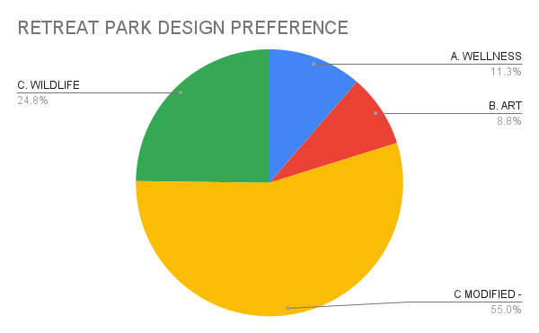

|  |  |  |
| --- | --- | --- |
| **#** | **%** | **Retreat Park Design Preference** |
| 524 | 55.0% | C-Modified - Wildlife Sanctuary & Habitat Restoration |
| 236 | 24.8% | C. Wildlife Sanctuary & Habitat Restoration |
| 108 | 11.3% | A. Wellness & Mindfulness |
| 84 | 8.8% | B. Art & Culture in the Park |
| 952 | 100% | TOTAL |

PREFERENCE FOR TYPE OF ACCESS

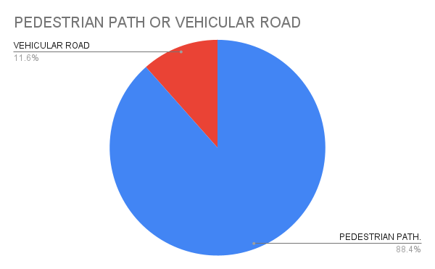

|  |  |  |
| --- | --- | --- |
| **#** | **%** | **Preference for Pedestrian or Vehicular Road Access** |
| 842 | 88.4% | Pedestrian Path |
| 110 | 11.6% | Vehicular Road with Parking Lot |
| 952 | 100% | TOTAL |

Quiet Waters Park - Retreat Park Survey

Summary of 300 Comments

Among 952 Total Respondents

After selecting their preferred design, respondents were invited to offer comments, summarized below.

Design C - Modified - Wildlife Sanctuary & Habitat Restoration

195 COMMENTS

524 Respondents preferred C - Modified or 55% of all respondents.

Respondents prioritize minimal development and preserving the natural habitat. Key points include protecting wildlife, ensuring animal sanctuary with minimal human impact, removing invasive species, planting natives, and avoiding roads, structures, or paved areas. Support for pervious trails and modest amenities like benches, with limited calls for small pavilions or comfort stations. Use Boathouse for education on environment and wildlife.

Overall, respondents favor a "less is more" approach to maintain the park's ecological integrity and natural beauty.

Design C - Wildlife Sanctuary & Habitat Restoration

50 COMMENTS

236 Respondents preferred C - Wildlife Sanctuary & Habitat Restoration or 25% of all respondents.

Respondents expressed appreciation for design’s balance of nature preservation and thoughtful human use. Respondents support habitat restoration, biodiversity, and minimal tree removal. Support for ADA-accessible trails, comfort stations, and family-friendly amenities. Prefer low-impact structures, e.g. small, multipurpose facilities and picnic areas. Opposed to increased traffic and parking to maintain peace. Suggest blending elements like outdoor classrooms and the "Restoration Pier."

Overall, respondents value natural beauty, educational opportunities, and minimal development.

Design A - Wellness & Mindfulness

30 COMMENTS

108 Respondents preferred A - Wellness & Mindfulness or 11% of all respondents.

Respondents support for general accessibility, minimal environmental impact, and key features like yoga platforms, sensory trails, and hammock groves. Respondents favor natural trails, value inclusivity for mobility-impaired users, and emphasize preserving green spaces with native plants. Criticism includes parking lots, park admission fees and dissatisfaction with the design selection process.

Design B - Art & Culture in the Park

25 COMMENTS

84 Respondents preferred B - Art & Culture in the Park or 9% of all respondents.

Respondents support for the boardwalk, sculpture garden, boat education center, and accessible trails. Suggestions include adding yoga spaces, art classes, ziplines, and pollination zones, while enhancing safety and accessibility. Concerns focus on cost, natural aesthetics, and removing unnecessary roads. Many prefer combining features from Designs A and B.

Quiet Waters Park - Retreat Park

Desired Key Features and Amenities

Of Preferred Park Design

On December 7, 2024, the Stakeholder group met to discuss our communities’ reaction to the proposed park designs. The following key features emerged as desirable for the Retreat Park. These key features are minimalistic and consistent with the survey respondents most preferred designs, C and C-Modified.

1. A Council Ring or Skywatch Grove close to the Retreat Park entrance is a desirable gathering space for groups. Use seating made of natural materials, e.g., stone, logs, etc.
2. Boathouse is desirable to be rehabilitated and used as both a viewing platform and a gathering space for group activities such as education, yoga, etc. Its’ structure may be enclosed with four walls or open with as little as one wall.
3. A deck or modest boardwalk below the Boathouse would support viewing Loden pond’s restoration and wildlife activity without excessively disturbing the shoreline and wildlife.
4. Viewing areas in grassy clearings are desirable overlooking both Loden Pond and at the cliffs overlooking South River. Prefer use of natural materials, e.g., stone or logs for any seating areas.
5. Several benches and picnic tables located in the vicinity of the cliffs overlooking the South River. The more rustic, the better.
6. A small, roofed and possibly rustic gazebo for shelter from weather, located in the vicinity of the South River cliffs.
7. The central path width may be as minimum as necessary for ADA compliance, preferably 8 feet wide with a permeable surface. The main path’s shape is preferred to be curvaceous and end near the South River cliffs with a meandering path that returns back towards the entrance (not a geometric loop).
8. Comfort station located outside of the Retreat Park entry area, accessible to main park’s path.
9. Two permanent ADA-compliant handicap parking spots located outside the Forest Hill gate to ensure access and independence for persons with disabilities.
10. Maintenance shed located west of Dog Park parking lot.

Quiet Waters Park - Retreat Park

Design Objectives of Proposed Concepts

In October 2024 when initially presenting the three design concepts, the County stated the following design objectives and proposed key features. These descriptions help to understand the concepts.

Design A - Wellness and Mindfulness

Establish Quiet Waters Park as a sanctuary for mental and physical well-being, with spaces designed for relaxation, reflection, and holistic health practices. This concept focuses on promoting wellness through passive, low-impact engagement with nature, ensuring minimal disruption to sensitive conservation areas like Loden Pond.

Key features are: Hammock Grove, Meditation and Yoga spaces, Nature viewing platform, Serenity path.

Design B - Art and Culture in the Park

To celebrate the rich history and cultural heritage of Quiet Waters Park through art and historical interpretation, making it a hub for cultural engagement in a natural setting.

Key features are: Cultural heritage trails (plaques, art installations, etc.), Sculpture garden, Art @ the Park large pavilion for events, Boathouse Learning Lodge, Skywatch Grove gathering area, Woodland arts and crafts studio.

Design C - Wildlife Sanctuary and Habitat Restoration

Create a sanctuary focused on wildlife protection and habitat restoration, with an emphasis on educational outreach to promote environmental stewardship. This concept prioritizes passive interaction with sensitive ecosystems like Loden Pond, preserving the area for conservation while providing educational opportunities for visitors.

Key features are: Reforestation and Pollinator Meadows, protected habitat areas near South River and Loden Pond, native plant restoration and removal of invasive plants, sustainable/eco-friendly picnic areas, Council Ring gathering area.